Comparison of MCMC and SMC for calibrating soil parameters in braced excavation

Comparaison de MCMC et de SMC pour l'étalonnage des paramètres du sol dans l'excavation étayée

Ningxin Yang, Le Truong *

*Civil and Environmental Engineering, Imperial College London, United Kingdom*

Luan T. Nguyen

*Ruhr-Universität Bochum, Universitätsstr, Bochum, Germany*

\**truong.le@imperial.ac.uk (corresponding author)*

**ABSTRACT:** Data assimilation has gained significant attention for the sequential updating of soil parameters, particularly in the context of braced excavation process. Incorporating numerical modelling into data assimilation is a key approach in achieving this. Traditional manual calibration is infeasible in this setting. As a solution, continuous Bayesian calibration provides a formal approach to merge measured data with model predictions, thereby improving the inversion process. In this study, two prevalent sampling methods, namely the Markov chain Monte Carlo (MCMC) and Sequential Monte Carlo (SMC), are compared based on a synthetic braced excavation. Leveraging incrementally acquired wall deflection observations during construction, parameter identification can be conducted sequentially. Results from MCMC and SMC based on the excavation problem are compared systematically. The results reveal that MCMC-derived uncertain variables are iteratively constructed based on random walk, while SMC-derived uncertain variables are represented by updating weights on the survived particles. This study also states the effectiveness of the two methods in sequential Bayesian updating and outlining their respective pros and cons when identifying soil parameters.

**RÉSUMÉ :** L'assimilation de données a suscité beaucoup d'attention pour la mise à jour séquentielle des paramètres du sol, en particulier dans le contexte du processus d'excavation étayée. L'incorporation de la modélisation numérique dans l'assimilation de données est une approche clé pour y parvenir. La calibration manuelle traditionnelle est inapplicable dans ce cadre. En tant que solution, la calibration bayésienne continue offre une approche formelle pour fusionner les données mesurées avec les prédictions du modèle, améliorant ainsi le processus d'inversion. Dans cette étude, deux méthodes d'échantillonnage prédominantes, à savoir la chaîne de Markov Monte Carlo (MCMC) et le Monte Carlo séquentiel (SMC), sont comparées sur la base d'une excavation étayée synthétique. En tirant parti des observations de la déflexion acquises de manière incrémentielle pendant la construction, l'identification des paramètres peut être effectuée de manière séquentielle. Les résultats de MCMC et de SMC basés sur le problème d'excavation sont comparés de manière systématique. Les résultats révèlent que les variables incertaines dérivées de MCMC sont exprimées par des moments (moyenne et variance), tandis que les variables incertaines dérivées de SMC sont représentées par des particules survivantes. Cette étude souligne également l'efficacité des deux méthodes dans la mise à jour bayésienne séquentielle et énumère leurs avantages et inconvénients respectifs lors de l'identification des paramètres du sol.

**Keywords:** Data assimilation, Bayesian calibration, Excavation, MCMC, Particle filter

# intruduction

Back-analysis or inverse analysis based on field observations (or measurements) in a braced excavation process has been widely reported (Juang et al., 2013; M.K. Lo and Y.F. Leung 2018; Jin et al., 2021). Among many available inverse methods (e.g., least squares method, maximum likelihood method and Bayesian method), Bayesian updating approach provides a quantitative framework to update the input parameters probability distributions by incorporating initial assumptions on soil properties (prior probability) and observed data. However, in practice, braced excavations are carried out in stages. This leads to a requirement for a recursive update of soil parameter identification across multiple stages. Through a sequential Bayesian calibration, the updated soil parameters facilitate the predicted wall deflections with improved fidelity in the subsequent excavation stages. This process can be repeated stage by stage until the final excavation depth is reached.

When the soil parameters have been updated, a practical challenge is that the posterior obtained can usually not be calculated analytically and must therefore be approximated numerically. In geotechnical engineering, the prevailing standard solutions are Markov Chain Monte Carlo methods (see Andrieu et al., 2003 for an overview). Very briefly, the idea of an MCMC is to specify a Markov process that performs a random walk in parameter space, thus achieving continuous calibration. A widely-used alternative to MCMC sampling are Sequential Monte Carlo (SMC) algorithms. The core concept of an SMC is to generate a population of parameter sets, often referred to as “particles” (e.g., particle filter), which are iteratively filtered according to their fitness to the observed data. Despite many calibration studies have been conducted based MCMC and SMC, so far, there have been limited serious attempts to address the differences against each other in an excavation problem.

In this study, we aim to address these issues by giving an overview on the principles of MCMC and SMC. Then based on a synthetic multi-stage excavation with known soil parameters, the feasibility and effectiveness of the two sampling approaches are tested and compared.

# SAMPLING METHODS

The aim of sampling is to approximate the posterior $p(z|y)$ for the soil parameters $z$. Efficient sampling methods are a big topic of active research, with numerous techniques proposed in the past few years. In this study, however, our primary focus is on the two prevailing sampling methods, MCMC and SMC. Both methods are based on the idea of Monte Carlo approximation. The idea is straightforward: generate some (unweighted) samples from the t-th step posterior, $z_{t}^{s}\sim p\left(z_{t}|y_{t}\right)$, and then use these to aggregate any quantity of interest $E\left[f|y_{t}\right]≈\frac{1}{S}\sum_{s=1}^{S}{f\left(z_{t}^{s}\right)}$ given suitable function *f*. By generating enough samples, we can achieve any desired level of accuracy we like.

Both MCMC and SMC can be employed in sequential Bayesian inference for soil parameters in excavation. The overall structure of sequential Bayesian inference is summarized in Figure 1. Throughout the excavation steps, the posterior of the unknown parameters $z_{t}$ at the current stage $t$ is fed into the inference as prior at the next stage $t+1$. As new observation $y_{t}$ become available, new stage parameters $z_{t+1}$ can be updated. Though MCMC and SMC share the common ingredients during the Bayesian inference, there are some differences on the sampling. Next, we will have a brief look on these two sampling methods.

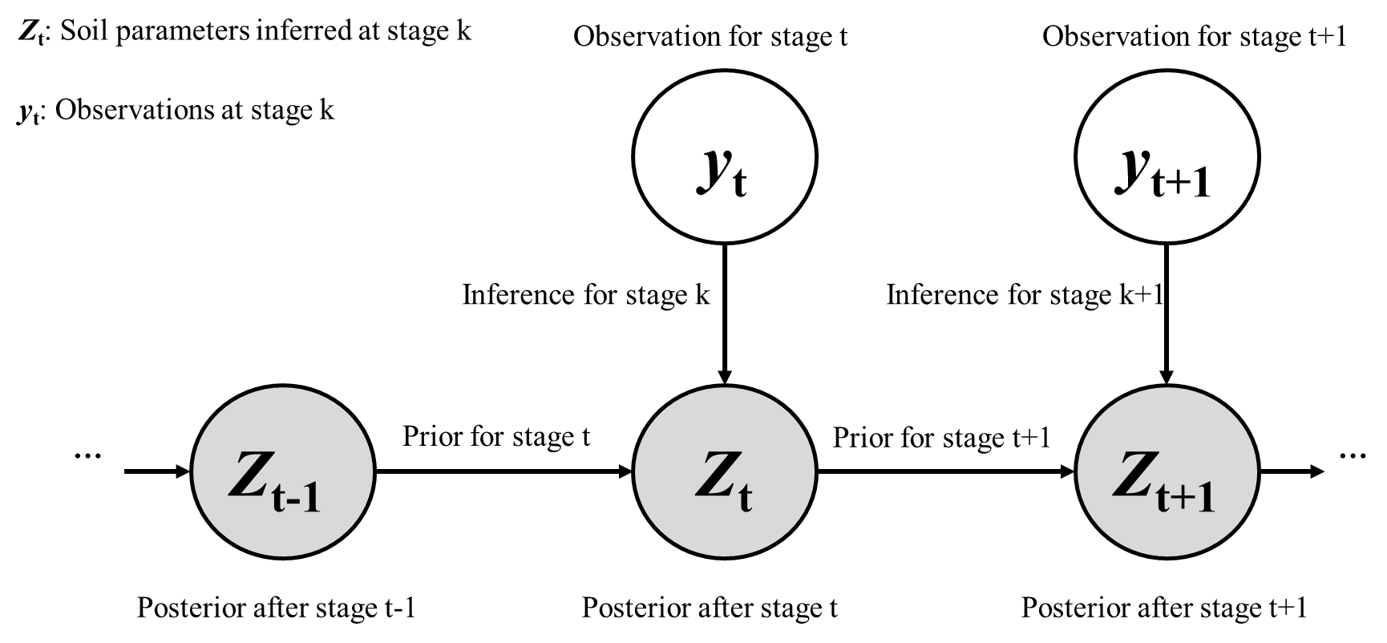

Figure 1. Sequential Bayesian inference for soil parameter

## Markov Chain Monte Carlo (MCMC)

Markov Chain Monte Carlo (MCMC) algorithms are methods for randomly sampling from a complicated distribution based on Markov chains. Different from non-iterative Monte Carlo methods (e.g., rejection sampling or importance sampling), MCMC can build a series of dependent and sequential samples. Instead of drawing samples independently, the samples in the Markov chain depend on the last adjacent sample. Many different MCMC sampling techniques share similar ingredients. For simplicity and clarity, here we take Metropolis–Hastings (MH) algorithm as example, but alternative more effective sampling methods can be also easily implemented.

The basic idea in MH is to define a proposal distribution $q\left(z_{t}^{s+1} | z_{t}^{s}\right),s=1,…,n$, between two adjacent samples from the current sample point $z_{t}^{s}$ to the new point $z_{t}^{s+1}$. If we have the first sample $z_{t}^{1}$, we can generate the later samples for any number $n>1$. These samples are used to describe the distribution of soil parameters $z_{t}$. For any given distribution $p(z_{t}^{s})$, we define the acceptance function, which used to decide whether to accept this move, as follows:

$$f\left(z_{t}^{s+1} | z_{t}^{s}\right)=\min\left(1,α\right)$$

$$α=min⁡(1,\frac{q(z_{t}^{s}|z_{t}^{s+1})p(z_{t}^{s+1}|y_{t})}{q\left(z_{t}^{s+1} | z_{t}^{s}\right)p(z_{t}^{s}|y_{t})})$$

If $α>1$, which implies $q(z_{t}^{s}|z_{t}^{s+1})p\left(z_{t}^{s+1} | y_{t}\right)>q(z_{t}^{s+1}|z_{t}^{s})p(z_{t}^{s}|y_{t})$, we accept the candidate sampled point from $q(z_{t}^{s}|z_{t}^{s+1})$. If $α<1$, we accept the candidate point with probability $α$. If the candidate is accepted, the new sample point is $z_{t}^{s+1}$ otherwise is stays the same. A commonly used proposal distribution is Gaussian distribution centered on the current point $z_{t}^{s}$. The acceptance function can be modified as:

$$f\left(z_{t}^{s+1} | z_{t}^{s}\right)=\min\left(1,α\right)=\min\left(1,\frac{p\left(z_{t}^{s+1}\right)}{p\left(z_{t}^{s}\right)}\right)$$

The process of MH sampling is shown in Algorithm 1. It is worth mentioning that although the proposal distribution can be any distribution, the closer it is to the actual target distribution, the more efficient the chain mixture would be. Also, we need to assign an initial position that is not zero probability. Although the initial position does not affect the convergence of MCMC, a good initial guess would help to accelerate mixing for a Markov chain. With more paralleled chains and iterative steps used, the convergence will be improved accordingly. In this study, we adopt 800 steps and 30 chains to get good levels of convergence.

|  |  |
| --- | --- |
| Algorithm 1 Metropolis Hastings algorithm at t-th step | |
| 1 Initialize $z_{t}^{0}$; | |
| 2 **for $s=1,2,…n$** **do** | |
| 3 | Define $z_{t}^{}=z_{t}^{s}$ |
| 4 | Sample ; |
| 5 | Compute acceptance probability $α$; |
|  | Compute ; |
| 6 | Sample $u\sim U\left(0,1\right)$; |
| 7 | Set new sample to |
|  |  |

In a multi-stage excavation problem, the posterior of the calibrated soil parameters $z_{t}$ can be readily explored and extracted with paralleled MCMC. Based on these distributions, we can then draw samples for predictive purpose. Additionally, upon acquiring new observations $y_{t+1}$ in the subsequent stage, the soil parameters $z_{t}$ can be updated using obtained samples $z_{t}^{s}$ as priors for the next stage, ensuring a continuous calibration for $z_{t+1}^{}$.

## Sequential Monte Carlo (SMC)

SMC, also known as particle filter, is always initialized by generating a population of independent particles (each particle corresponding to a possible soil parameter set). The SMC will now filter these particles in a way that the final distribution of particles approximates the posterior distribution. This filtering typically consists of three steps: initial samples, weighting, and resampling, which are iteratively applied while new observation is added at each iteration.

The recursive filtering process can be treated as a predict-correct step shown in Algorithm 2. Each particle generated is assigned a weight, usually proportional to its likelihood $L(z_{t}|y_{t})$. In the next step, the particles are resampled with replacement, with their sampling probabilities given by their normalized weights $ω_{t}^{s}$. This means that particles with low weights (bad fit) tend to be discarded, whereas particles with high weights (good fit) are more likely to be saved.

|  |  |
| --- | --- |
| Algorithm 2 Particle filtering | |
| 1 **for $s=1,2,…n$** **do** | |
| 2 | Draw |
| 3 | Compute weight ; |
| 4 Normalized weights: $ω_{t}^{s}=\frac{ω_{t}^{s}}{\sum_{s=1}^{S}{(ω_{t}^{s})}}$; | |
| 5 Resample | |

Unlike MCMC samplers, where new soil parameter sampling point $z_{t}^{s+1}$ is generated based on the current $z_{t}^{s}$, SMC sampling points $z_{t}^{s}$ can be processed simultaneously. To be consistent and comparable with MCMC, SMC adopts 5000 particles to update the soil parameters.

# Model setup

Based on Chen 2020, a symmetric 2D FE excavation model has been set up using Imperial College Finite Element Program (ICFEP). This excavation was performed using bottom-up construction method in nine stages (with a final excavation depth of 28.9m) with the support of concrete diaphragm walls and steel props. The wall is modelled as a beam element, and the props are modelled as bar elements only accounted for axial force. The soil elements adopt modified Cam Clay model with small strain stiffness model. The soil profile and the excavation depth in each stage are shown in Figure 1. From the ground downward, the soil profile has six layers accordingly: made ground, Terrace Deposits, London clay, Lambeth Group, Thanet sand and chalk. The excavaton width is 13.5m and the extension length for the mesh is 100m to avoid boundary effect. Details for the model setup and construction stages can be referred to Chen 2020.

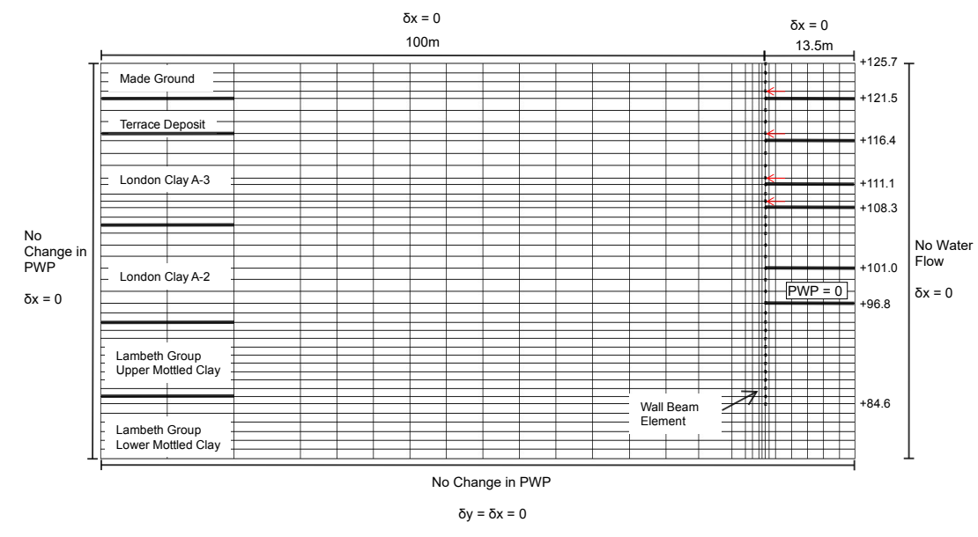*Figure 2. Detailed configurations of the excavation.*

During the Bayesian updating process, however, the practical issue is that it can become quite complex with increasing layers and soil parameters. This expansion in the number of parameters to be updated would require greater computational resources. However, this study goals to focus on the differences of MCMC and SMC samplers in excavations. To simplify the Bayesian updating process while preserving the effect of individual soil layers, we only

Table 1 Summary of analysis and soil parameters for calibration

|  |  |  |  |  |  |
| --- | --- | --- | --- | --- | --- |
| Case | Input parameter range (MPa) | | Ground truth (MPa) | Sampler method | FE Simulation runs |
| A | G1 | 10-20.2 | 14.7 | MCMC/SMC | 30 |
| G2 | 53-227.4 | 92.2 | MCMC/SMC |
| B | G1 | 10-20.2 | 14.213 | MCMC/SMC | 120 |
| G2 | 53-227.4 | 62.915 | MCMC/SMC |
| G3 | 38.9-150 | 64.906 | MCMC/SMC |
| G4 | 53.5-150 | 85.774 | MCMC/SMC |
| G5 | 55-183 | 97.856 | MCMC/SMC |
| G6 | 55-183 | 138.519 | MCMC/SMC |

consider small strain stiffness of each layer, namely G1 to G6, respectively. Table 1 summarize the soil parameters used in the analysis. Case A performs 30 runs for G1 and G2 parameter identification only. Case B performs 120 runs for G1 to G6 updating. The ranges for the input parameters are large enough assumed as a very difficult situation in which very little prior knowledge can be obtained. To establish comparability between MCMC and SMC, for example, we employ 119 runs designated as the training dataset, while one left run, subjected to a 3% Gaussian noise, serves as the measurement. The benchmark values of G1 to G6 are deterministic and known. Notably, the ground truth remains excluded from the training data, rendering it unknown to both MCMC and SMC. Typically, the total number of runs is controlled by the computational time of the FE model, and as such, there are no fixed rules in place. In this study, the number of runs is chosen empirically using Latin hypercube sampling for a balance between accuracy and efficiency. Here, to generate the chains or particles, we do not run the simulation explicitly for each step. Instead, we emulate the simulation output using a surrogate model (PCE) that is fitted to the simulation results obtained over the range of calibration parameters run prior to the sequential Bayesian inference. It is worthy noted that even a surrogate is not necessarily required in SMC updating, to ensure the comparability with MCMC, the number of particles in SMC should be at least equivalent to chains/steps in MCMC.

# Results and discussion

## Case A

To visually see the working principles between SMC and MCMC, Case A only considers two input variables G1 and G2 in feasible ranges in table 1. Prior to sequential Bayesian calibration, it is common practice to perform sensitivity analysis (Sobol’s indices) to obtain a rough estimate of the most important soil parameter. The sensitivity analysis shows that the first-order index for G1 and G2 are 2% and 98%, respectively. In this study, despite G2’s dominant influence, G1 is still participating the Bayesian process to increase the complexity of inference. Figure 3 shows the evolving distributions of MCMC and SMC as excavation stages progress.

In SMC method as shown in Figure 3(a)-3(c), the underlying principle is to iteratively filter a population of particles regarding their fit to new observations. The color change in the figure reflects the resampling weight assigned to the particles, which gradually narrows down the confidence range until only a few particles with the highest weight remain. Practically, the weighting and resampling procedure of SMC is achieved using all the data at once. This non-iterative nature leads to particles being independent of each other. Consequently, it is necessary to generate all potential particles before the updating process. This means that the particle positions remain unchanged during the calibration process, as the updates primarily affect the weights assigned to the particles, rather than the particles themselves. However, in contrast, as depicted in Figures 3(d)-3(f), MCMC adopts a different approach. It treats the samples from posterior equally and specifies a random walk in parameter space. Unlike SMC, the samples in MCMC are not predefined and are constructed in a correlated manner. In Figure 3(d), the uniform distribution represents the non-informative prior. As new observation are incorporated, as shown in Figure 3(e), newly generated samples tend to be clustered near the vicinity of the observed data, while samples in less likely regions will be burned-in. After multiple stages of random walk and burn in, Figure 3(f) reveals the most likely region where the parameters are expected to reside.

Figures 4(a) and 4(b) illustrate the evolution of the mean value ($μ$) and the standard deviation () of G1 and G2 with respect to the excavation stages. Given the low Sobol’s index for G1 (2%), our primary focus is directed towards G2 values. In Figure 4(b), both

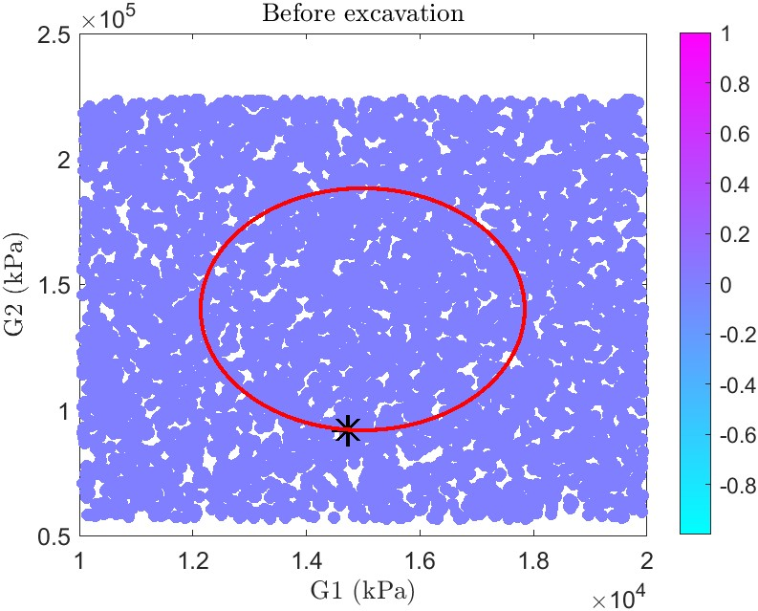 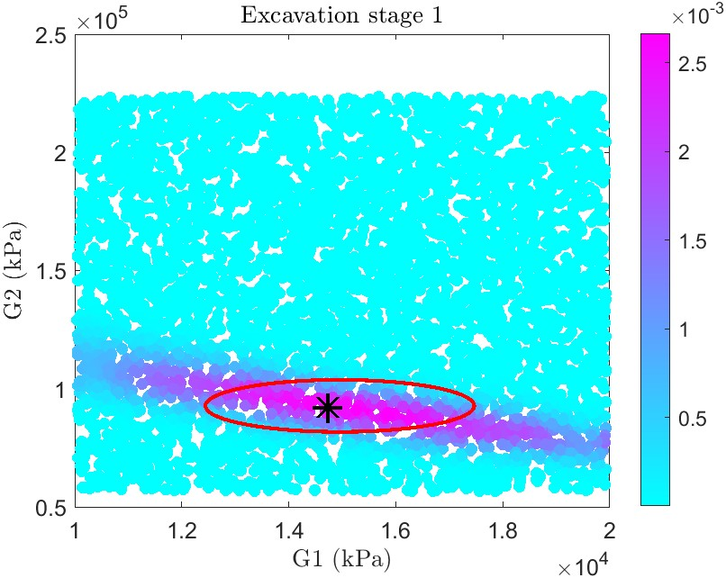 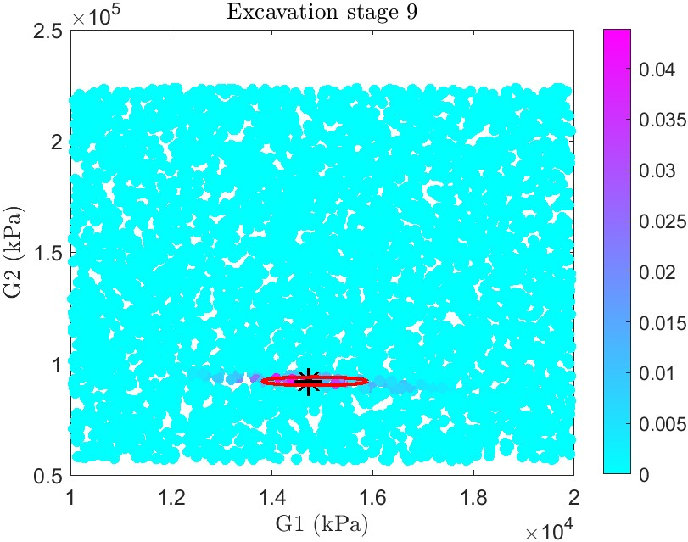

1. (b) (c)

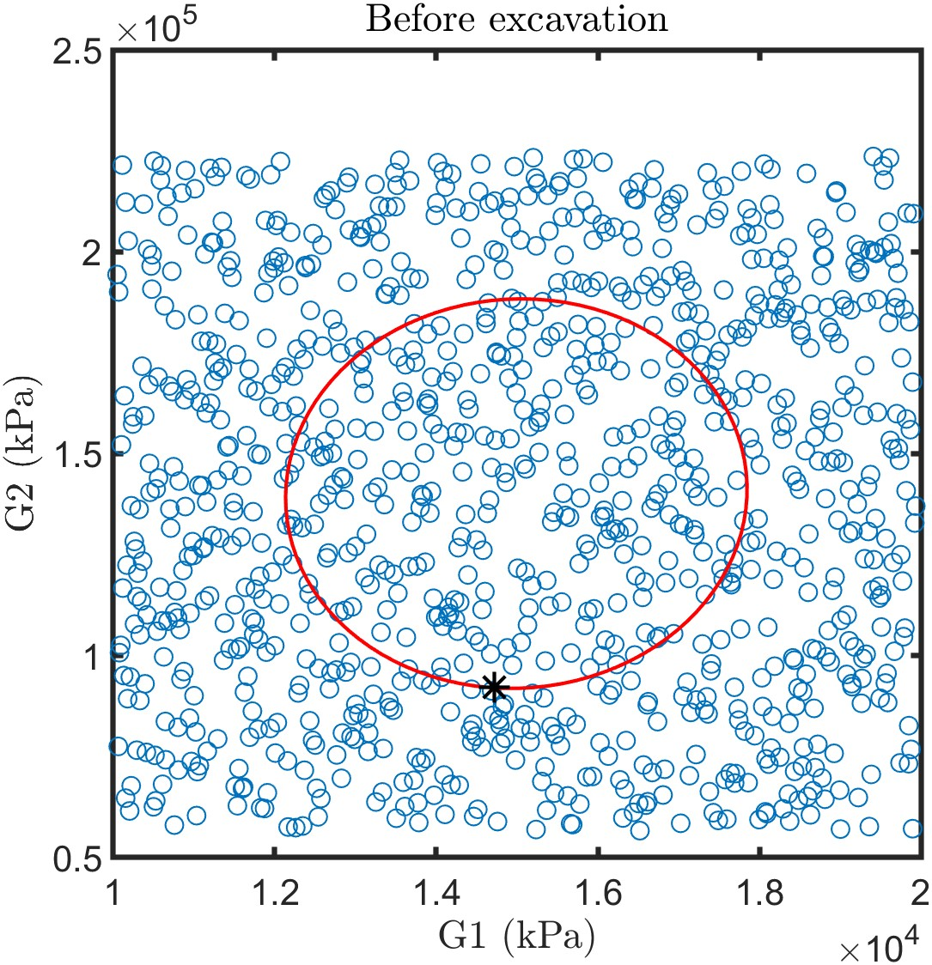 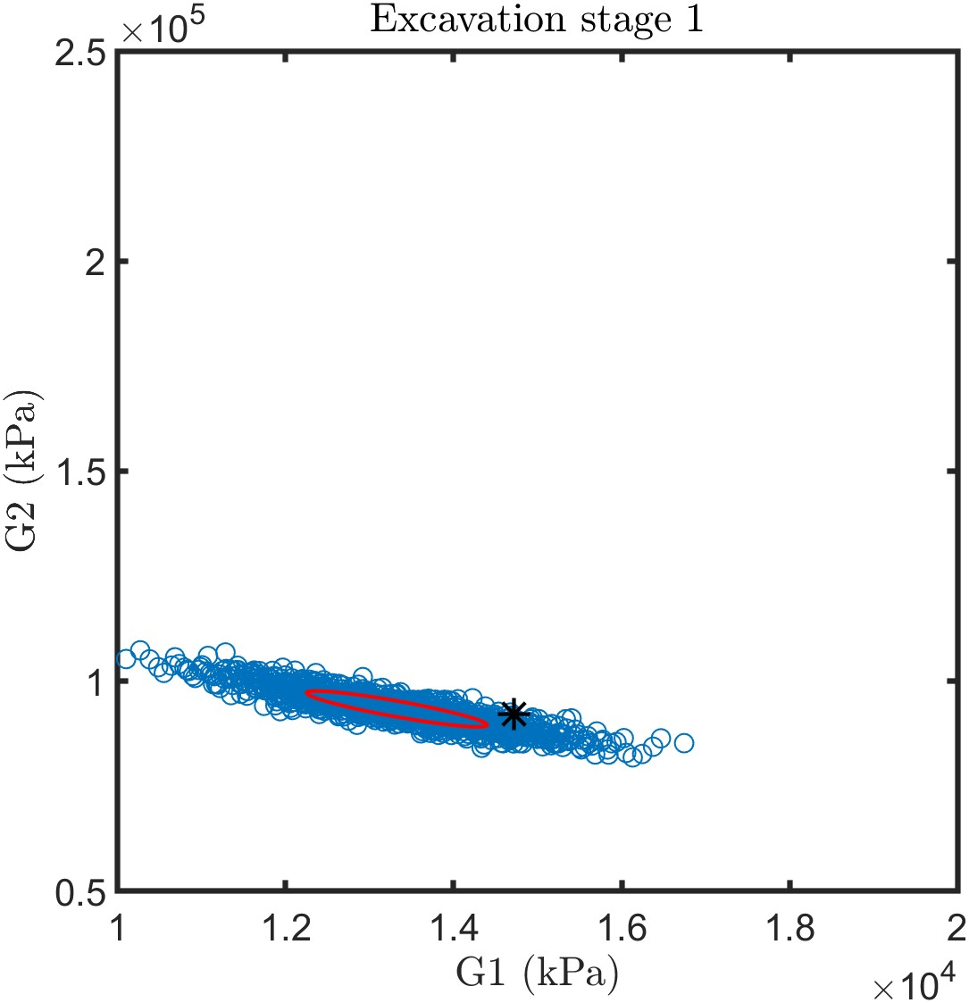 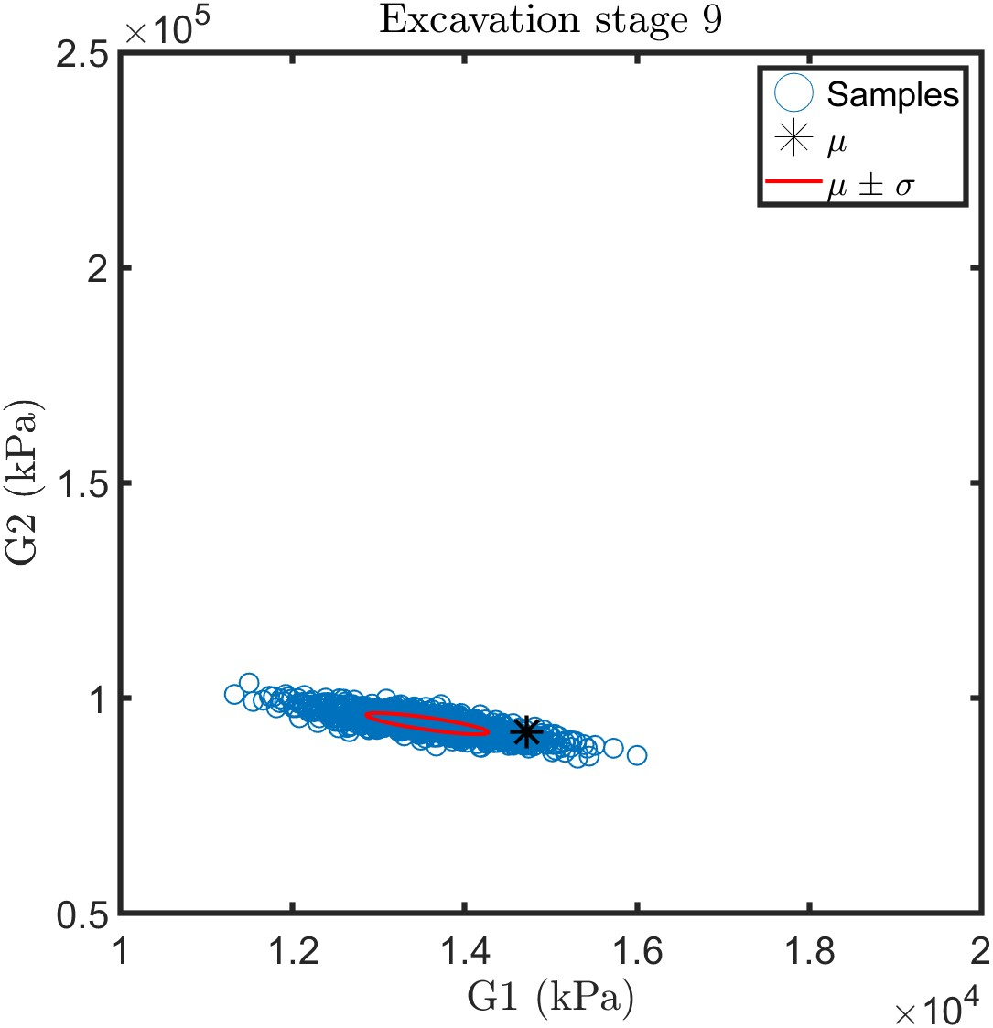

(d) (e) (f)

Figure 3 Bayesian Calibration of SMC and MCMC: (a)-(c) for SMC, (e)-(f) for MCMC

SMC and MCMC exhibit their ability to capture the ground truth, resulting in root mean square errors of 0.16% and 1.38%, respectively. In terms of computational efficiency, the models were executed on a PC equipped with a 32-core Intel(R) Xeon(R) Silver 4216 CPU @ 2.10GHz and 256GB of memory. SMC, employing 5000 particles, completes the analysis in a mere 10 minutes. In contrast, MCMC, with 800 steps and 30 chains, takes over 30 minutes to achieve the same results.

From the comparison, we can see the main difference: (1) With more information obtained from excavation stages, SMC achieves Bayesian updates by continuously adjusting particle weights, whereas MCMC employs a random walk approach to explore the parameter space. (2) The SMC approach is substantially quicker than the MCMC approach. 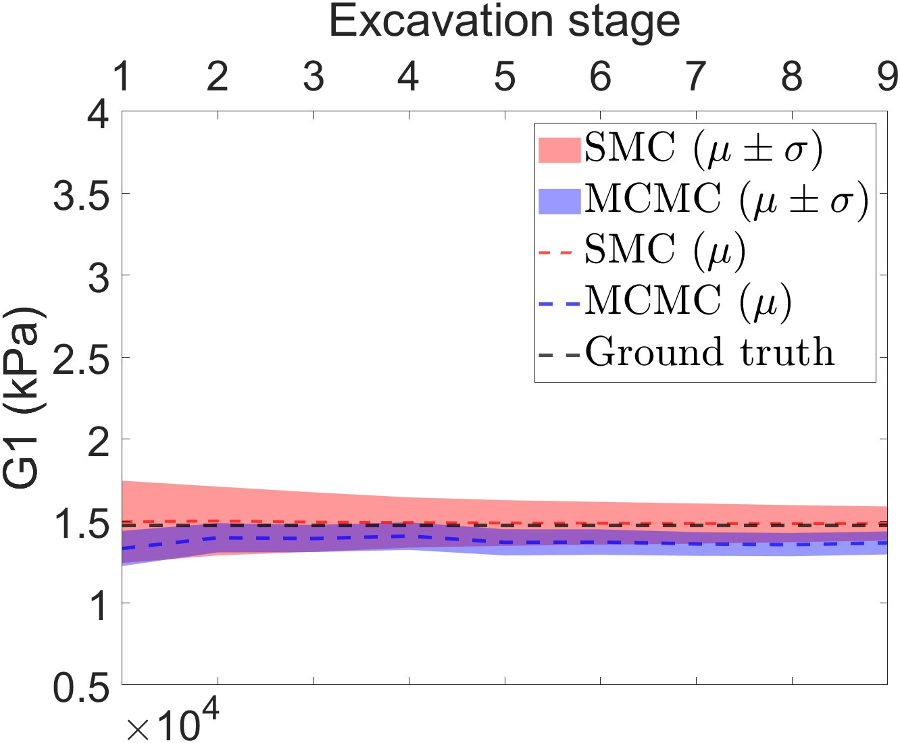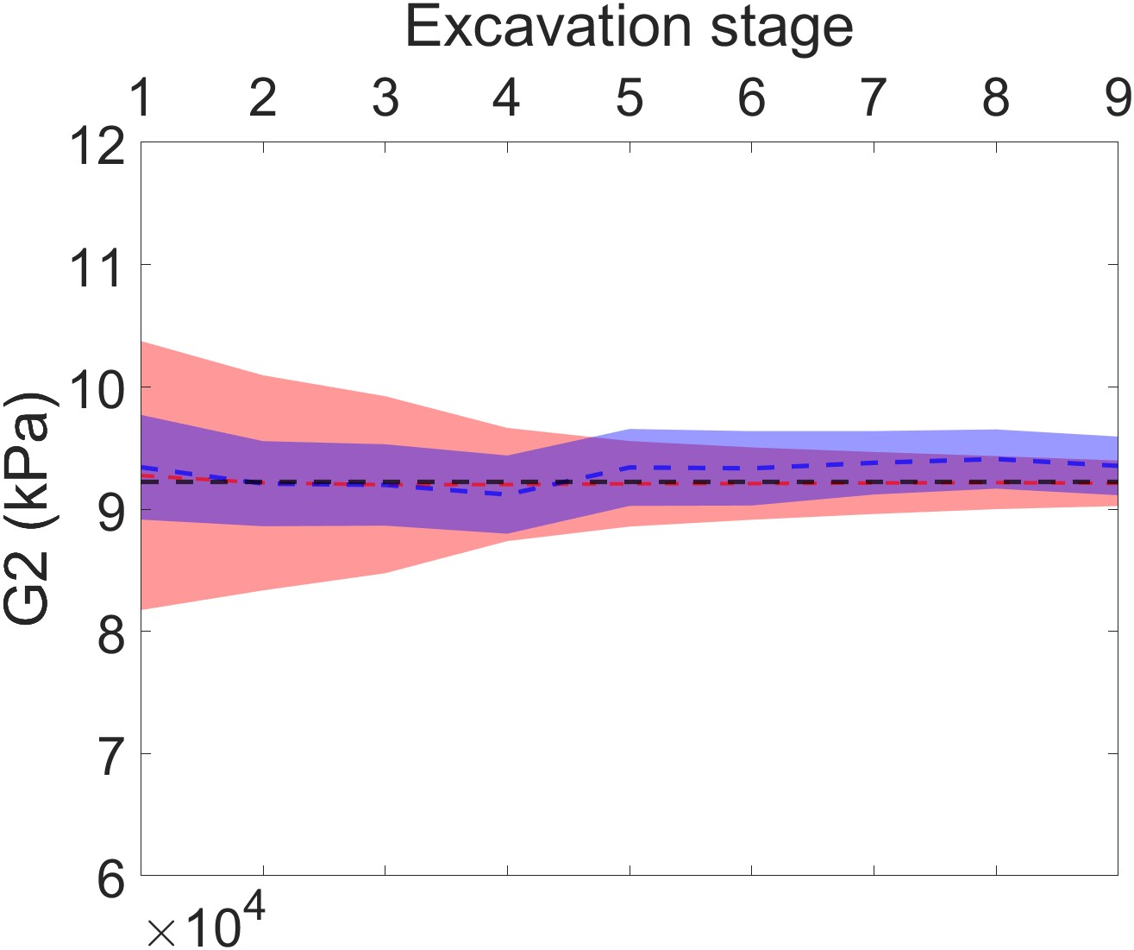

1. G1  (b) G2

Figure 4. Summary for SMC and MCMC in different excavation stages (a) G1 paramter (b) G2 paramter

## Case B

In Case B, we evaluate the performance of MCMC and SMC in a higher-dimensional space involving six soil parameters as outlined in Table 1. Sensitivity analysis reveals that G2 (17.3%), G3 (76.3%), and G4 (2.6%) are the most influential variables. Following Case A, all parameters from G1 to G6 are considered to increase the complexity of the inference process. Figure 5 summarizes the mean ($μ$) and one standard deviation ($σ$) confidence range for both MCMC and SMC as excavation progresses through various stages. Out of the 119 runs used to train a surrogate model, one is reserved as the ground truth for reference. Notably, G1, G5, and G6 struggle to approximate the ground truth due to their low Sobol's indices. Consequently, our subsequent analysis focuses solely on G2 to G4.

Shown as Figures 5(b)-5(d), both MCMC and SMC initially exhibit wider result spreads at the beginning of the analysis, which gradually narrow as excavation progresses. It becomes evident that SMC yields a smaller variance compared to MCMC. However, MCMC proves adept at exploring samples in high-dimensional spaces. As shown in Figures 5(b)-5(d), as we acquire new observational data, the posterior distribution obtained through MCMC effectively encompasses the true underlying information. In contrast, SMC does not assure the same level of accuracy and demonstrates more pronounced bias.

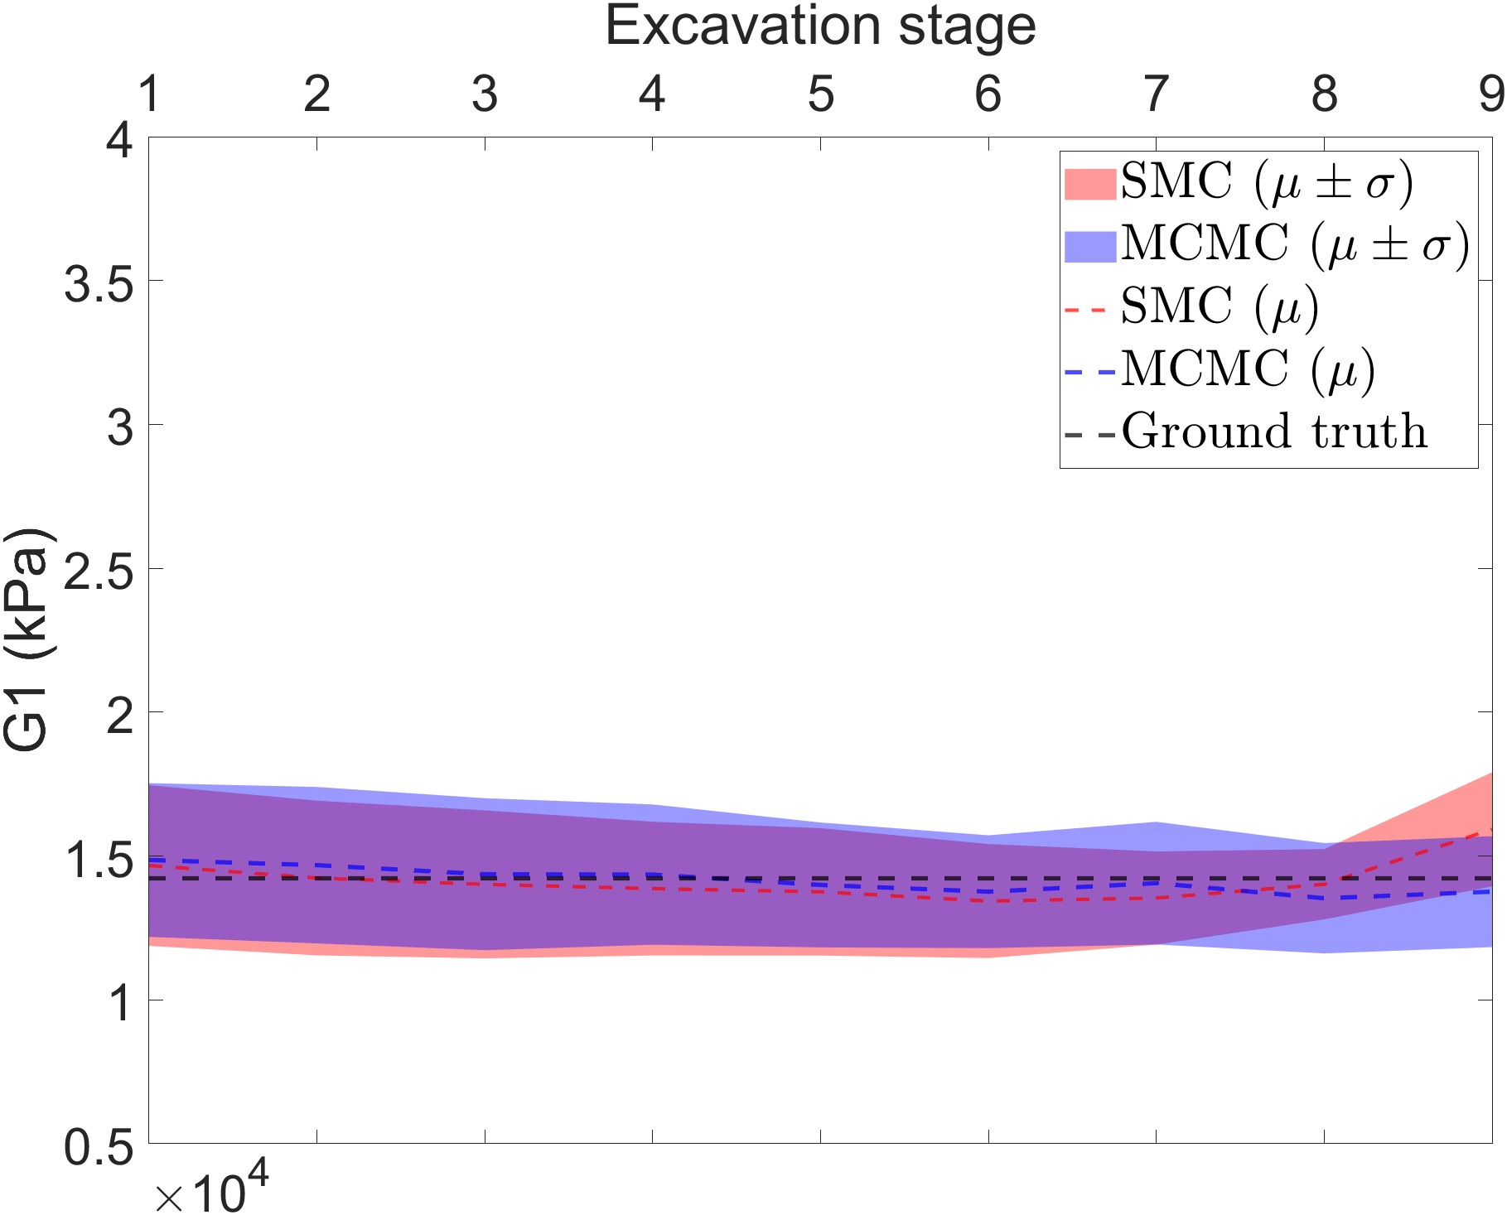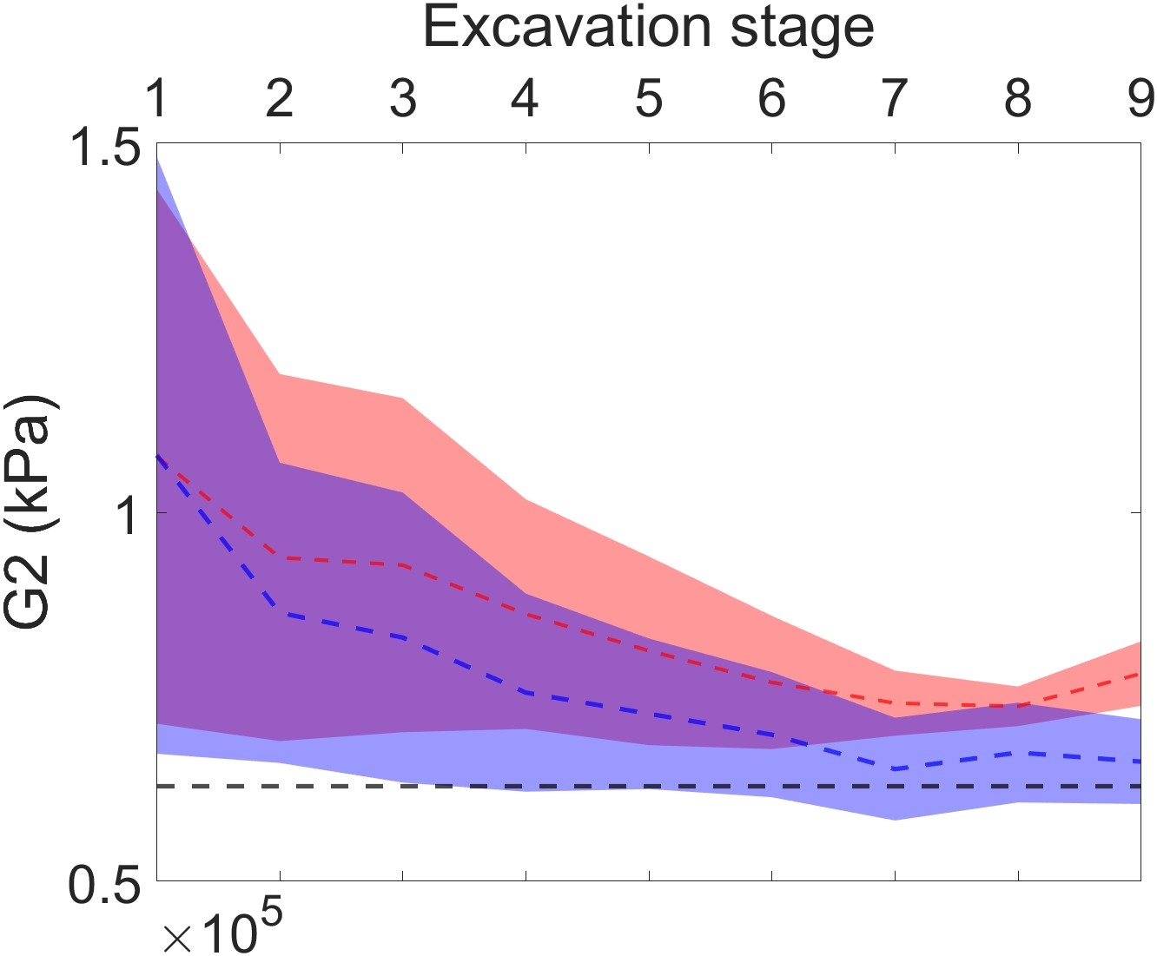 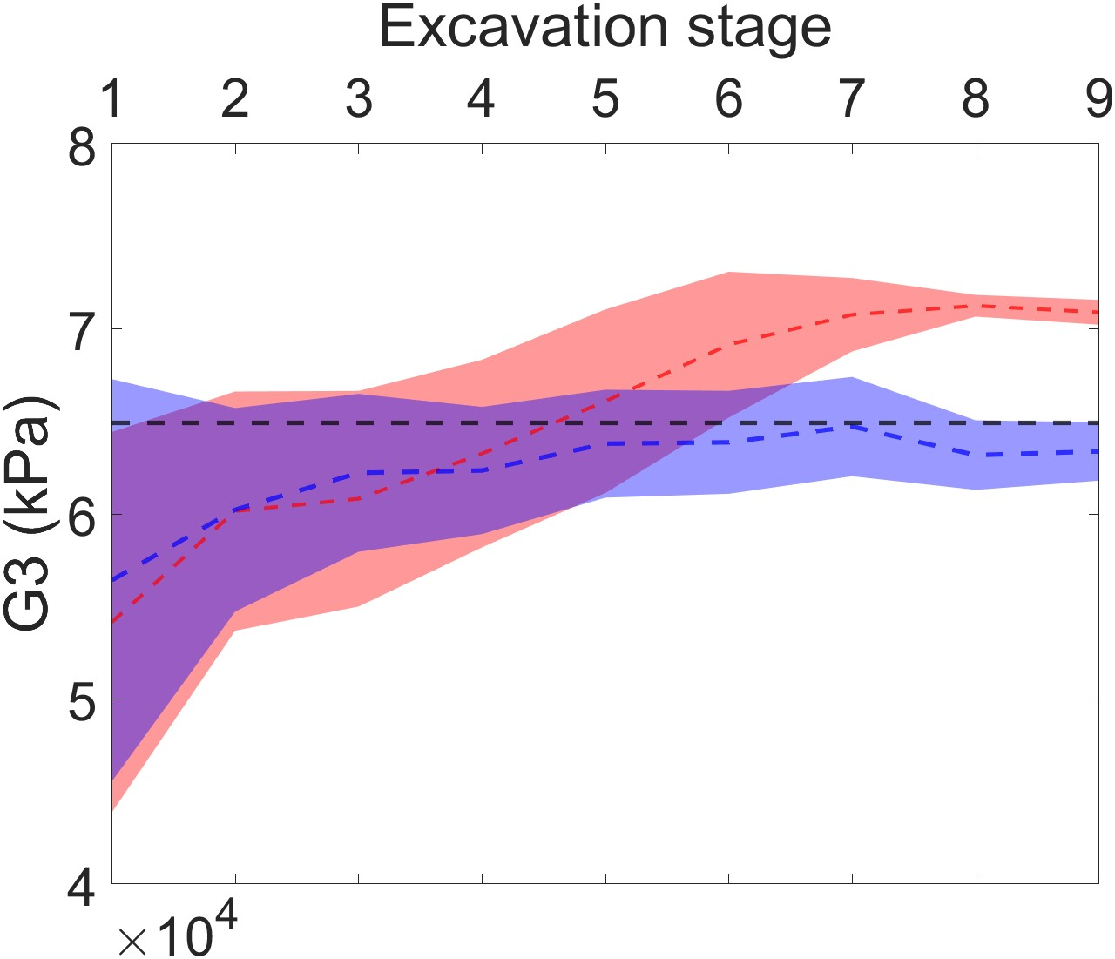

1. G1 (b) G2 (c) G3

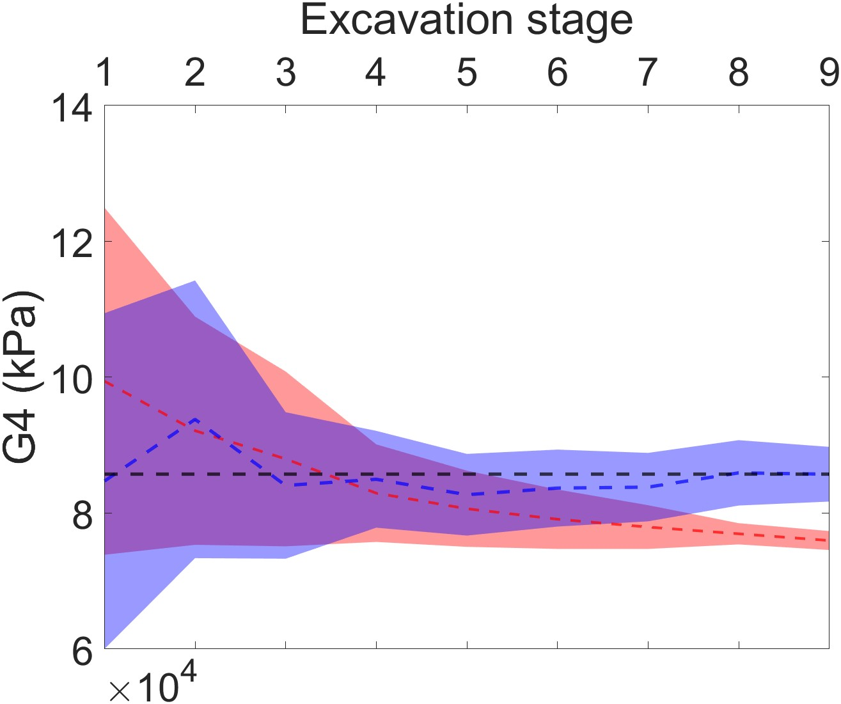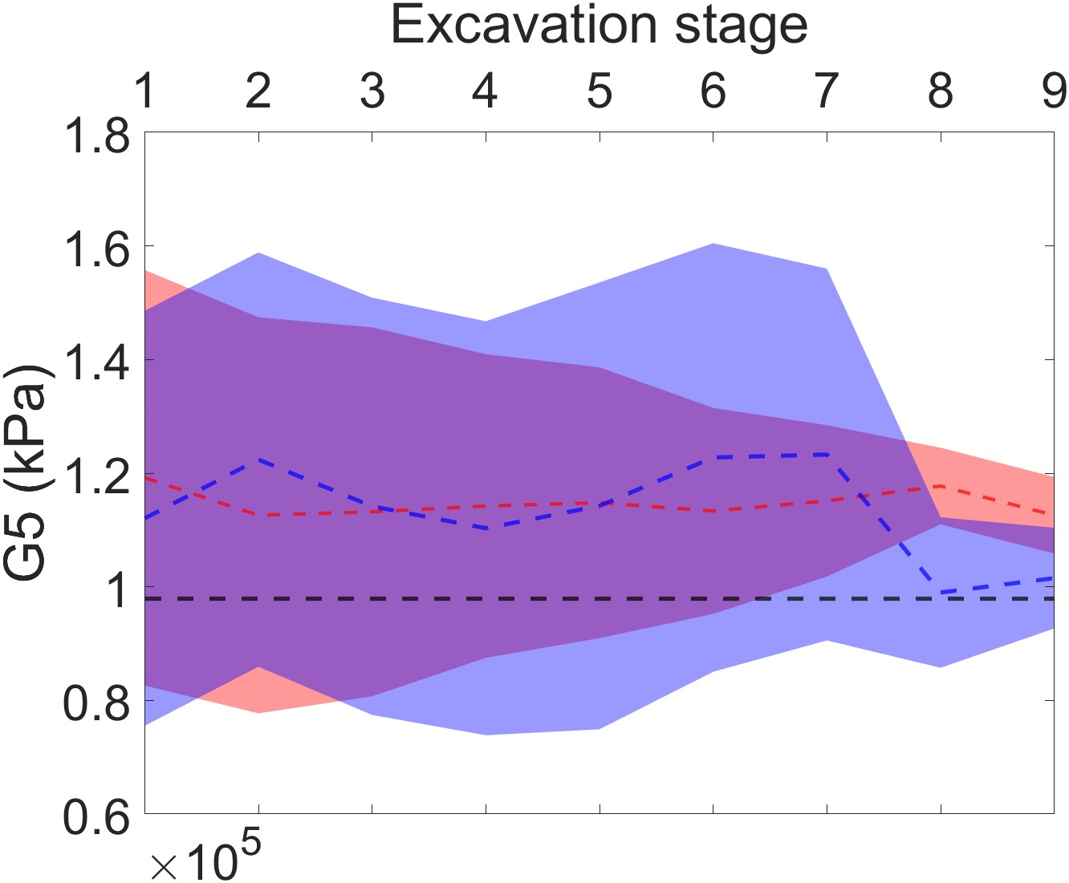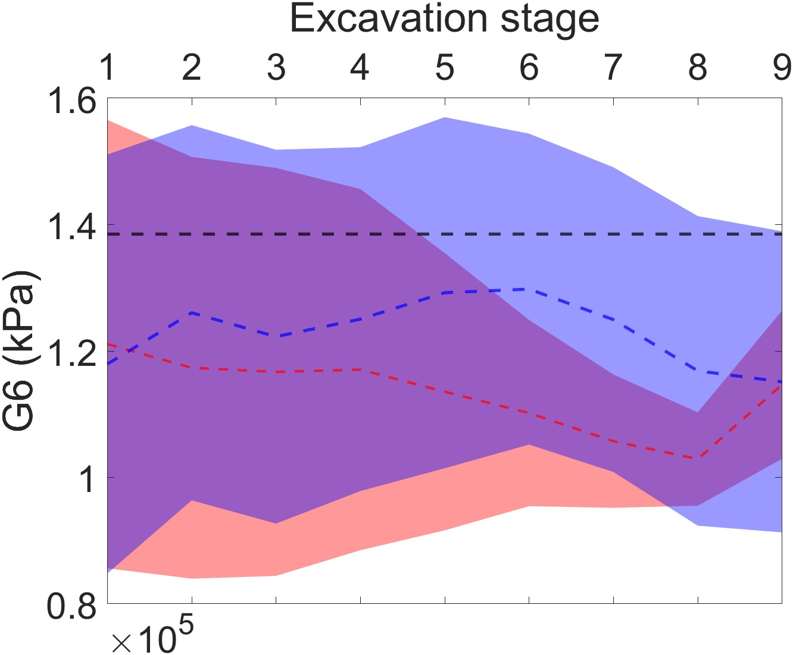

(d) G4 (e) G5 (f) G6

Figure 5 Summary for SMC and MCMC in different excavation stages for G1 to G6

# conclusion

This study conducted a comparative analysis of the performance of Markov Chain Monte Carlo (MCMC) and Sequential Monte Carlo (SMC) methods for calibrating soil parameters in the context of braced excavation. Both methods demonstrated their effectiveness in updating soil parameters, particularly in low-dimensional settings.

MCMC, with its random walk approach, showcased its proficiency in exploring high-dimensional parameter spaces, making it a suitable choice for complex and multifaceted problems. On the other hand, SMC, with its non-iterative nature, offered the advantage of parallel processing, significantly enhancing computational efficiency. This attribute makes SMC a favorable option when quick results are imperative. However, it is crucial to consider that SMC, while delivering rapid outcomes, might exhibit a narrower variance in results and may not guarantee the same level of accuracy as MCMC in high-dimensional scenarios. Therefore, the choice between these methods should be guided by the specific needs and priorities of the analysis, whether precision or computational efficiency takes precedence. This comparative analysis contributes valuable insights into the advantages and trade-offs of MCMC and SMC in the calibration process, particularly for applications in geotechnical engineering.

# ACKNOWLEDGEMENTS

This work is supported by XXX.

# References

